

# ALBERTO CLOCKS

**Supervisor:** *NGUYỄN HẠ VY*

**Semester:** *01*

**Batch No:** *T1.2210.A1*

**Group No:** *01*

|  |  |  |
| --- | --- | --- |
| **Order:** | **Full name** | **Roll No.** |
| *1.* | *LÊ GIA KIỆT* | Student1424198 |
| *2.* | *NGUYỄN DANH HƯNG* | Student1424193 |
| *3.* | *NGUYỄN XUÂN DƯƠNG* | Student1427717 |
| *4.* | *LÊ HẢI SƠN* | Student1424176 |

***Month:****1* ***Year****: 2023*



This is to certify that

**Mr. LÊ GIA KIỆT Mr. LÊ HẢI SƠN Mr. NGUYỄN DANH HƯNG**

**Mr. NGUYỄN XUÂN DƯƠNG**

Have successfully Designed & Developed

# ALBERTO CLOCKS

Submitted by:

**Ms. NGUYEN HA VY**

Date Of Issue:

Authorized Signature:

# Content

Content Acknowledge Synopsis

Review 1

Review 2

Review 3 ..

Tasksheet ..

# Acknowledge

As we understand that the eProject is a step-by-step learning environment that closely simulates the classroom and Lab-based learning environment into actual implementation. It is a project implementation at your fingertips!! An electronic, live juncture on the machine that allows you to.

* Practice step by step i.e. laddered approach.
* Build a larger more robust application.
* Usage of certain utilities in applications designed by user.
* Single program to unified code leading to a complete application.
* Learn implementation of concepts in a phased manner.
* Enhance skills and add value.
* Work on real-life projects.
* Give a real-life scenario and help to create applications that are more complicated and useful.
* Mentoring through email support.

First of all, I would like to thank India Aptech for allowing my team to work on this fantastic eProject. We had a great experience with eProject this time.

Next, We would like to express my special thanks to our mentor, Ms. Ha Vy for the time and effort that she provided throughout the project. Your helpful advice and suggestions were beneficial to us during the completion of the project. In this respect, We are forever grateful to you.

Besides several mistakes we made in the project, we hope to have more opportunities to widen our knowledge in the web-developing world.

We will try to continue to learn and improve ourselves even more in the future.

Yours Sincerely, Team Group 01.

# Synopsis

The Objective of this program we aim is to give a sample project to work on real- life projects. These applications help us build a larger more robust application.

The objective is not to teach us HTML/JavaScript but to provide us with a real-life scenario and help us create basic applications using the tools.

Hence, we can revise the chapters before we start with the project.

This project is meant for students like us who have completed the module of HTML5. These programs should be done in the Lab sessions with the assistance of the faculty if required.

The website (in this project) is a tool that brings everything in the world to you such as historic monuments information natural knowledge and skill in technology...

It is very essential for us that will have a clear understanding of the subject. We think we should go through the project and solve the assignments as per the requirements given.

And get back ***[eprojects@aptech.ac.in](mailto:eprojects@aptech.ac.in)*** as the assigned schedule.

## Problem Definition

Alberto Watch Company is a full-service watch repair, appraisal, and retail store –

offering the finest selection of luxury timepieces. Offering an unparalleled selection

with first-class service.

Alberto also carries a wide selection of brand new watches such as Michael Kors,

Rolex, Citizen Eco-Drive, Bulova and more!

You are supposed to create a Single-Page-Application and responsive Website for

them with the below mentioned requirement specifications.

The website is to be developed for the Windows Platform using HTML5, JSON,

Angular JS, JavaScript and Geolocation. The site should work well in all leading

browsers including Chrome, IE, Firefox etc.Requirement Specification**:**

The Web site is to be created based on the following requirements.

1) The Top of the Page should be presented with a suitable logo, and page

should have decent colour combination.

2) The site should display a menu which will contain the options as Products,

Technology, Store Locator, Support etc.

3) Various sections having information about different types of watches and

clocks, Technology used in the watches etc. these sections should display

products accordingly.

4) The information should be categorized in sections according to different

Product Line-up e.g. “Vintage”, “Luxury”, “Smart Watches” etc.

5) When a user selects any product line-up, complete list of watches for that

product line-up will be displayeds.

6) Details of the watches should be displayed on the popup window.

7) Price List for all watches should be available.

8) Gallery can be added for viewing different images.

9) Site map, Gallery, about us, Contact us link must be added.

10) About Us and Contact Us: This menu option should display Email id, address,

and contact number of the organization.

Over and above this, the portal should implement the following functionalities:

• Display a continuous scrolling ticker at the bottom of the page with current date,

time, and location (hint: Use geolocation features of HTML5).

• Display a visitor count at the top right corner of the page beside a logo image.

• The menu options should change color on hover and also after clicking.

• Fade in and fade out options can be used for the menus.

## Customer Requirements Specifications

### User:

#### input:

* Information on search.
* Data of registered members.
* Feedback to the webmaster.

#### Process:

* Find the searching
* Check the data of registered members.
* Check the feedback of users.

#### Output:

* Result of searching.
* Confirm the data of registered members.
* Confirm the feedback of the users.

### Hardware/ software requirement:

#### Software:

* + Notepad/HTML editor
  + Dreamweaver
  + IE 5.0/ Netscape 6.0

#### Hardware:

* + A minimum computer system that will help you access all the tools in the courses is a Pentium 166 or better
  + 64 Megabytes of RAM or be

|  |  |
| --- | --- |
| **Document Name**:  Architecture and design of the project | **SWD/Form** No.03/ARD/Ver1.0 |
| **Version** 1.0 | **Page 3** |

About

Blog

Watches

Login

Contact

1. **Interactive with web at Homepage**

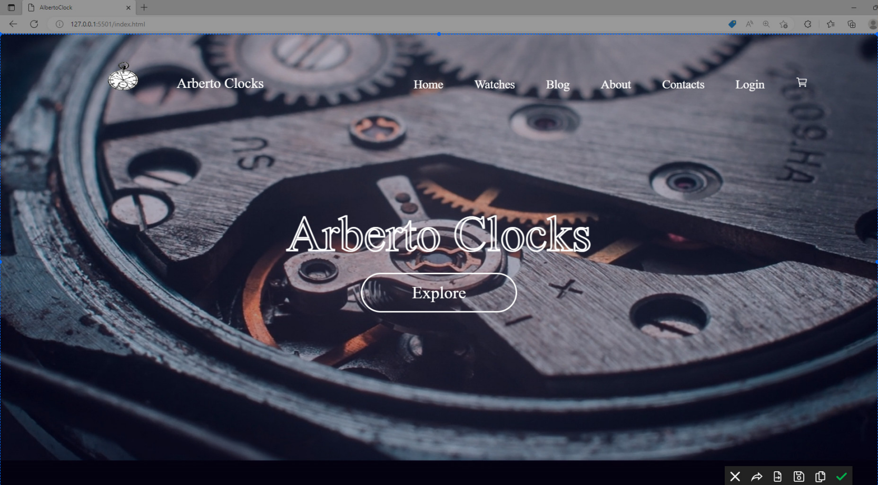

* + When you click icon 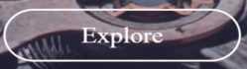 , it will go to Watches
  + When you click “Watches”. You go Watches page.
  + When you drag mouse to it , we have this hover

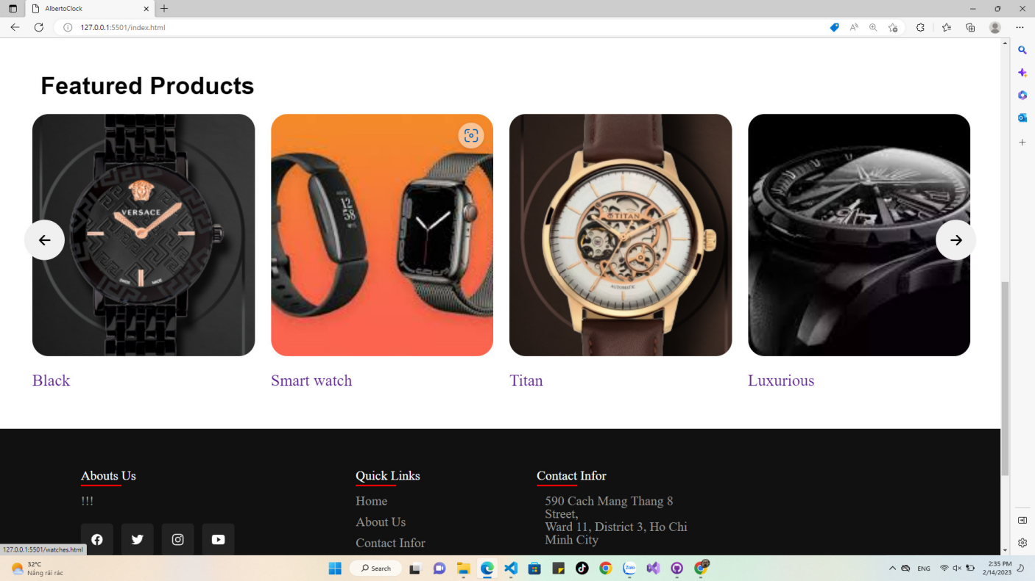

II.Watches

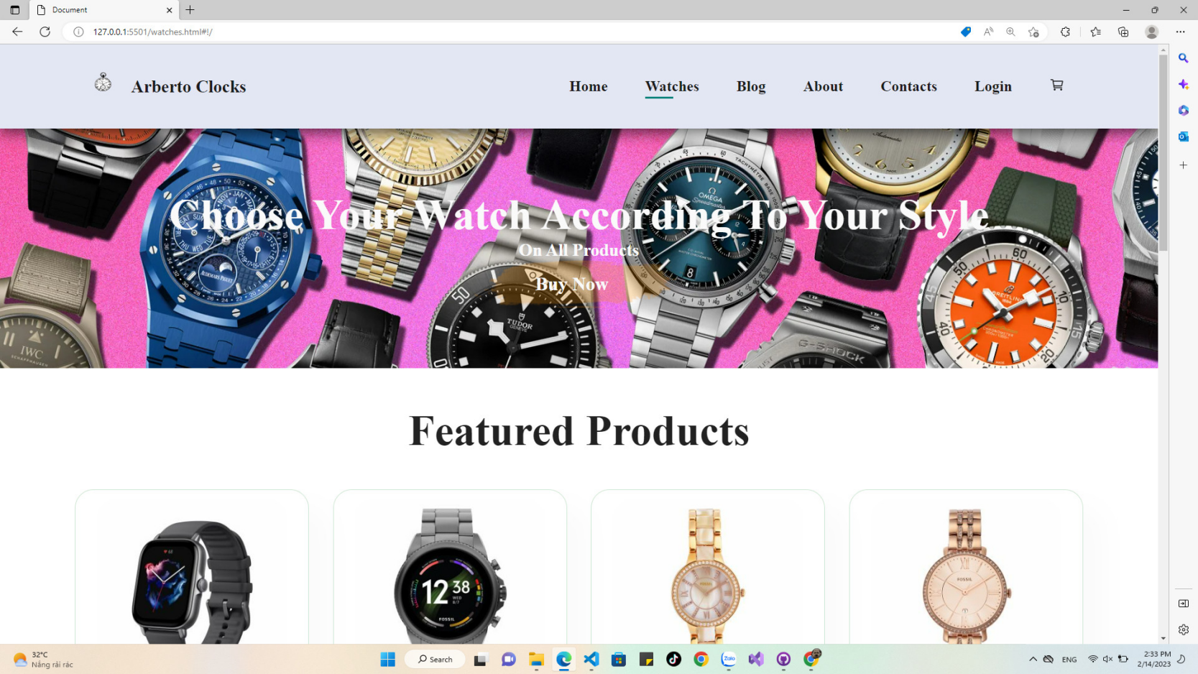

-This is Watches page.

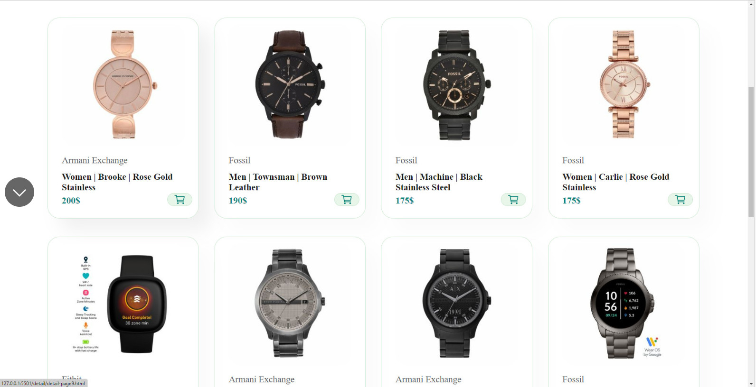

-Here is Menu.

-When you click “” , we go to details item page.

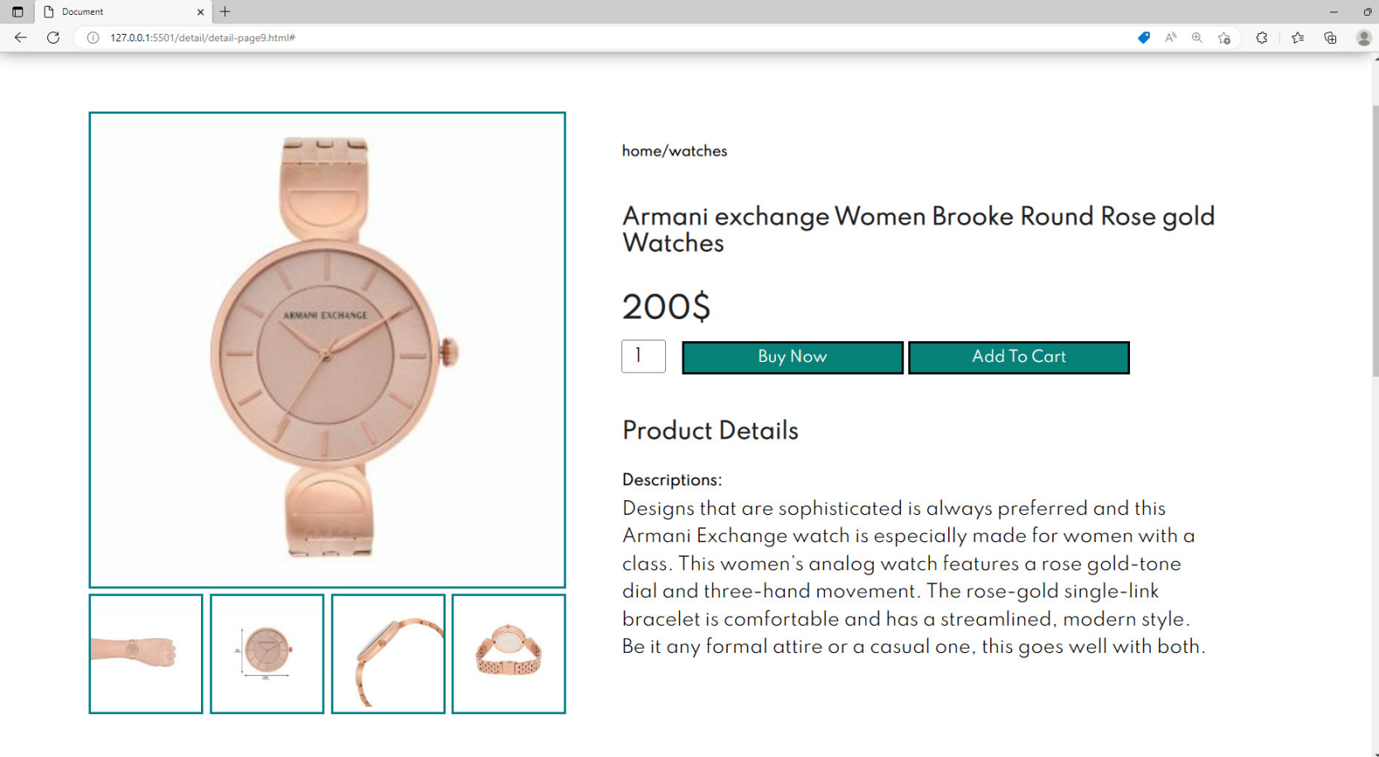

-This is Detail Page.

-When you click “Buy Now”, we go to payment page.

-When you click “Add To Cart”, we add this item to cart

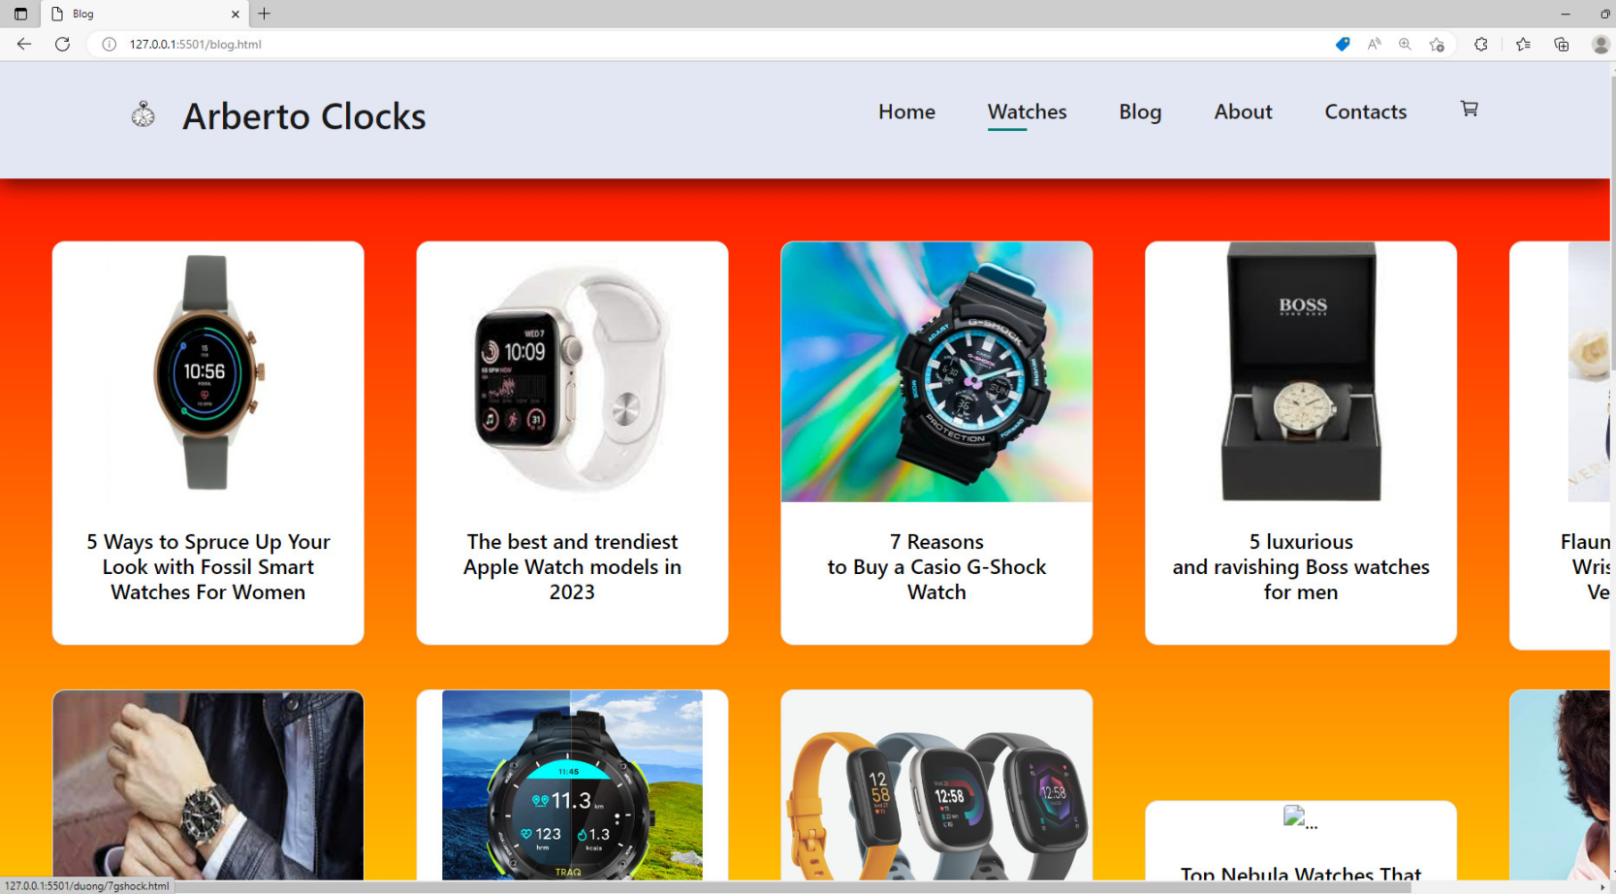

-When we click “Blog”, we go to blog page, this page show some information about watches.

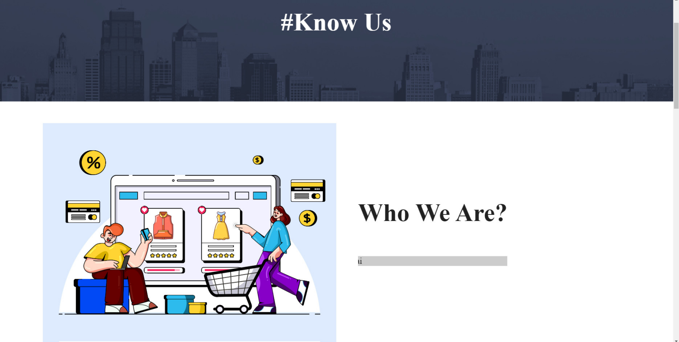

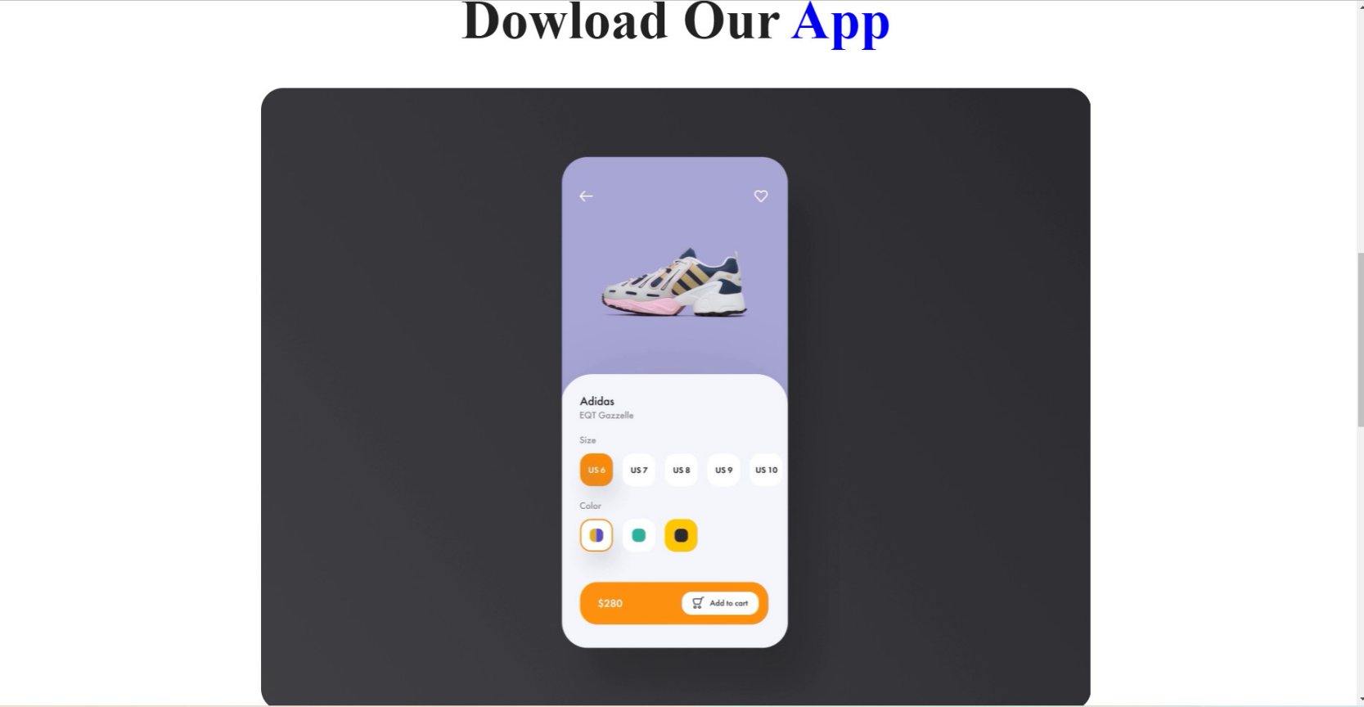

|  |  |  |  |  |  |  |  |
| --- | --- | --- | --- | --- | --- | --- | --- |
| No | Member | Contents | Page Name | Activity Plan | Date of Preparation of Activity Plan | | |
| Planed Start Date | Actual Start Date | Actual End Date | Status |
| 1 | Nguyễn Xuân Dương |  |  |  |  |  |  |
| Blog Details | Blog.html | 7/11/2023 | 9/11/2023 | 21/2/2023 | 70% |
| Blog | detail.html | 7/11/2023 | 9/11/2023 | 21/2/2023 | 70% |
| 2 | Nguyễn Danh Hưng | Menu | Menu.html | 7/11/2023 | 9/11/2023 | 21/2/2023 | 100% |
| Home | Index.html | 7/11/2023 | 9/11/2023 | 21/2/2023 | 100% |
| Product details | Detail.html | 7/11/2023 | 9/11/2023 | 21/2/2023 | 100% |
| About Us | About.html | 7/11/2023 | 9/11/2023 | 21/2/2023 | 90% |
| 3 | Lê Hải Sơn | blog | blog.html | 7/11/2023 | 9/11/2023 | 21/2/2023 | 70% |
| Cart | cart.html | 7/11/2023 | 9/11/2023 | 21/2/2023 | 70% |
| 4 | Lê Gia Kiệt |  |  |  |  |  |  |
| Login | about.html | 7/11/2023 | 9/11/2023 | 21/2/2023 | 80% |
| Signup | SignUp.html | 7/11/2023 | 9/11/2023 | 21/2/2023 | 80% |

- This is “About Us” page.

Task Sheet

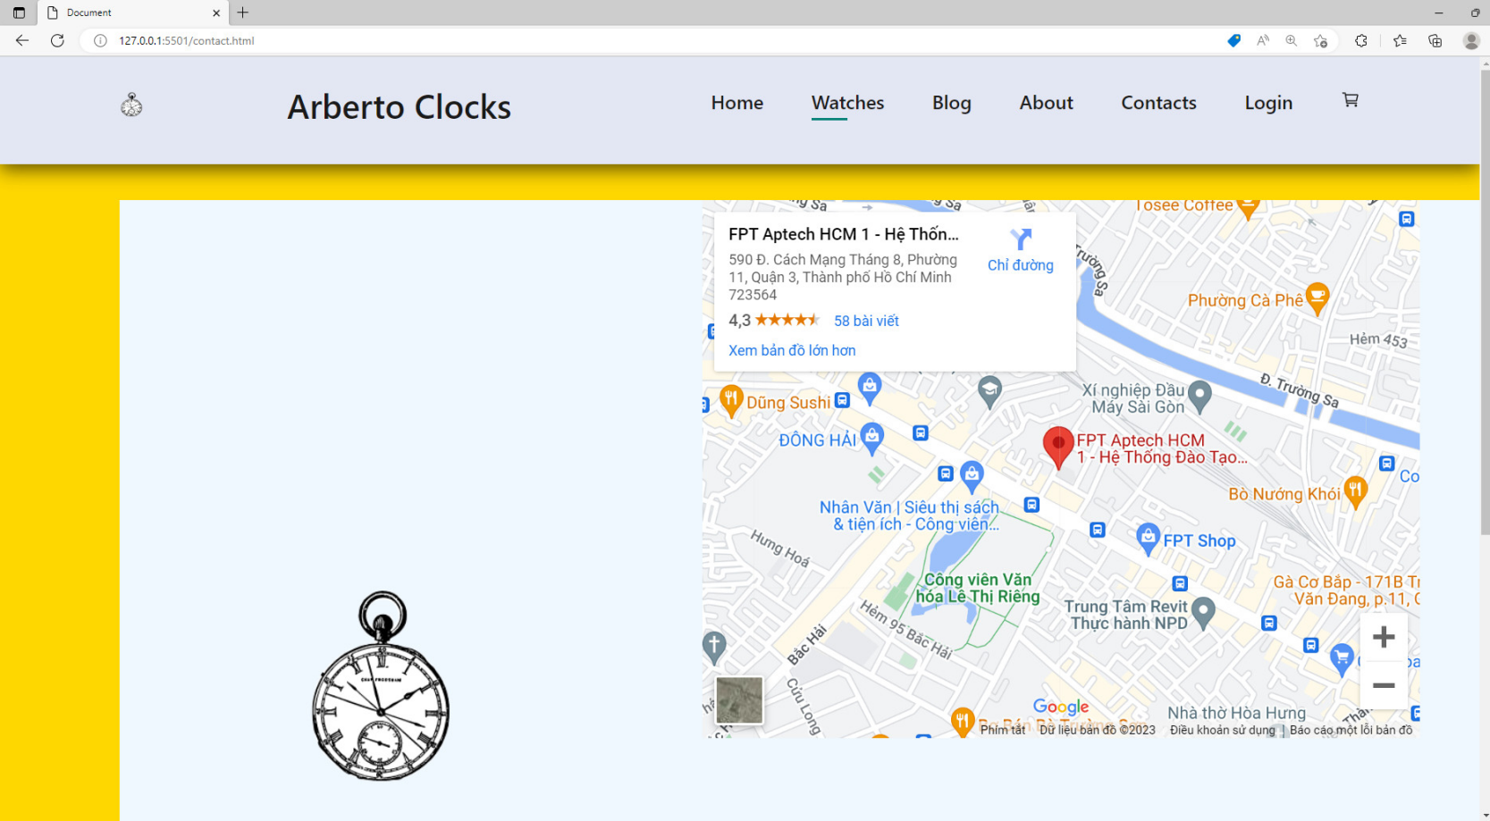

-This is “Contacts page”.

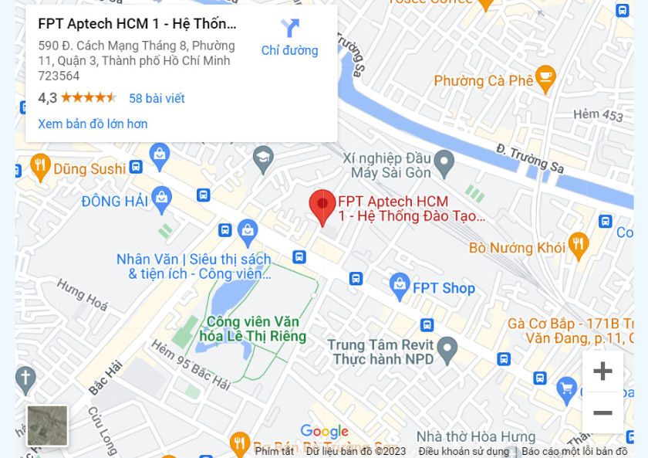

-We can drag mouse and use it like a map.

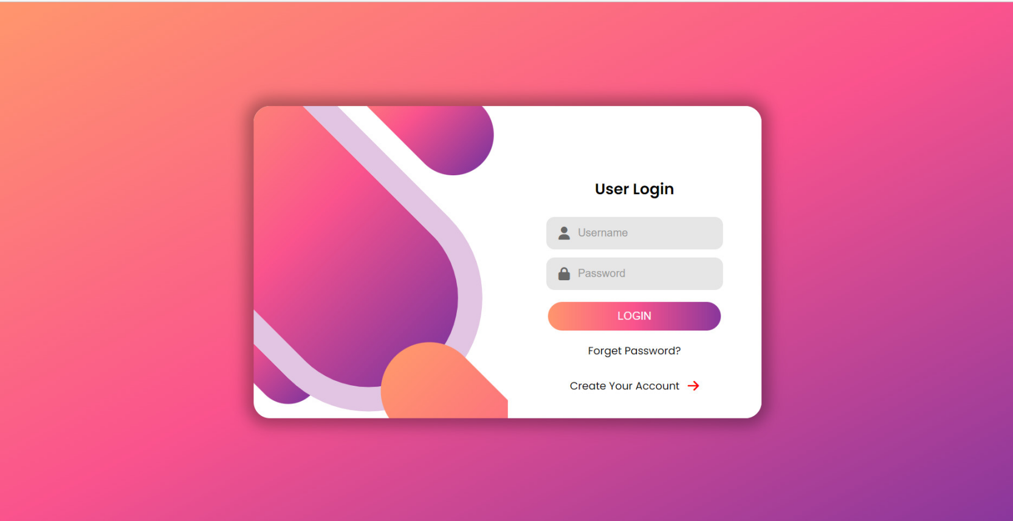

- This is Login Page , we can input name and password.

-When you click “Create Your Account”, we go to the next “Register Page”.

